**Happiness and Well-being Workshop**

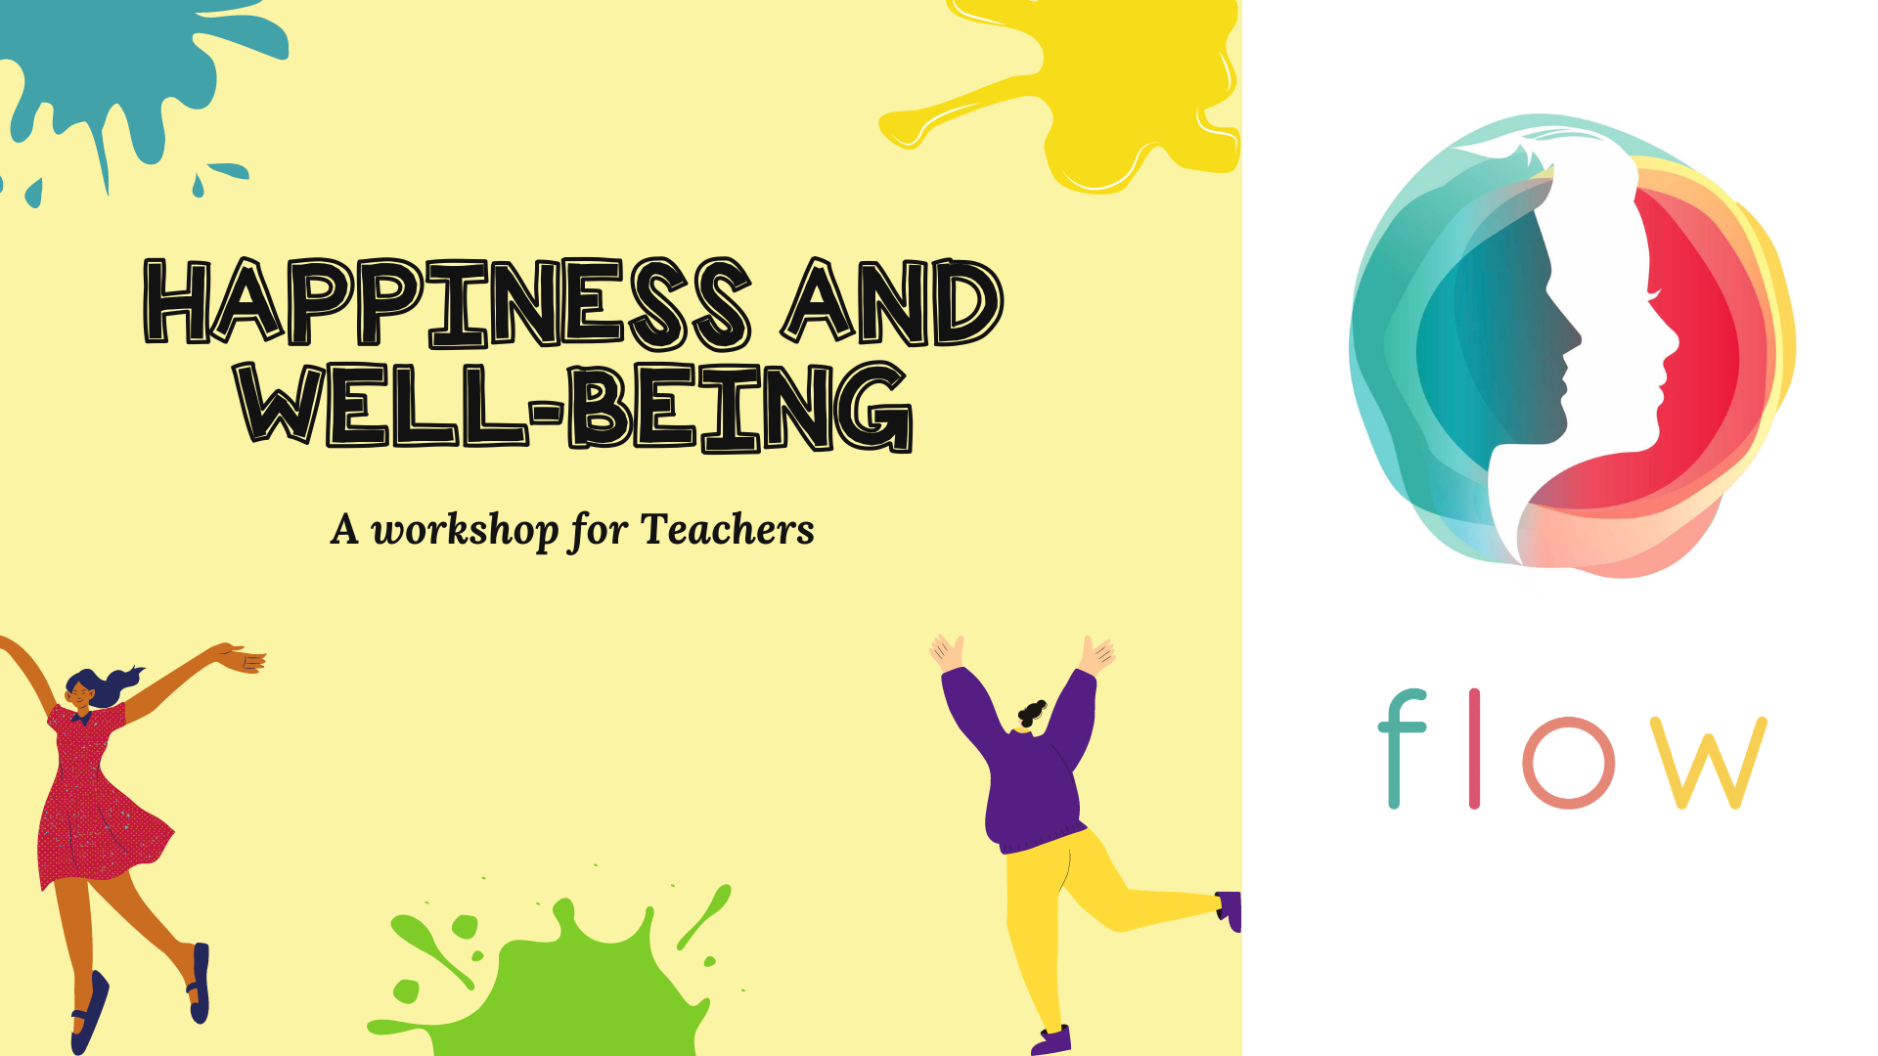

**Venue: B.P Pujari English Medium School (Raipur)**

**Date: 31st January 2021**

**Flow is all set to deliver a fun-packed session on happiness and well-being, which aims at re-energizing everyone’s waning spirits after having experienced a long period of isolation. This training program projects at giving new insights into the concept of happiness through various activities. Not only this, but every person attending the program is sure to get a space to explore, reflect and share their own personal ideas of happiness. Adding to the above there will be sharing of tools that the teachers can carry for lifetime to reorient and prioritize different aspects of their lives and well-being.**

**What to expect?**

* **Experiential learning**
* **Sharing of thoughts**
* **Fun packed activities**
* **Tips and tricks for overall well-being.**
* **Timeless tools to navigate life**

**Tap into the Flow for more fun and exciting events.**

**Facilitator’s name: Mr.** [Jenis Lunkad](mailto:jenislunkad@flowmenow.com)

**Co-facilitators: Mr.** [Calvin Cubbins](mailto:calvincubbins@flowmenow.com)

**Mrs.** [Raveena Bhui](mailto:raveenabhui@flowmenow.com)